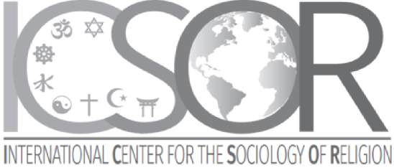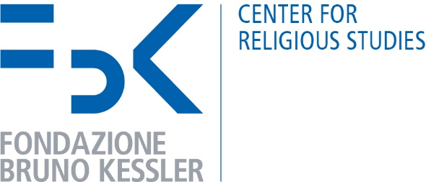
INTERNATIONAL FORUM ON RELIGIONS (1st-4th March 2023)
Università Roma Tre, Dipartimento Scienze della Formazione, via del Castro Pretorio 20, Rome
Organising Committee:
Irena Borowik, Roberto Cipriani, Grace Davie, Enzo Pace, Philippe Portier, Helena Vilaça, Fenggang Yang, Siniša Zrinščak
PROGRAMME
Wednesday 1st March 2023
9:00 - Introduction by Roberto Cipriani (Roma Tre University)
9:30 - Opening speech by Patrice Brodeur (University of Montreal)
Coffee break
11:00 - Lecture on “Judaism” by Sergio Della Pergola (Hebrew University-Jerusalem)
Discussants: David Meghnagi (Roma Tre University), Ephraim Tabory (Bar-Ilan University-Ramat Gan)
On-site catering
15:00 - Lecture on “Christian Churches” by José Casanova (Georgetown University-Washington)
Discussants: Anthony Blasi (St. Mary's University-San Antonio), Franco Garelli (University of Turin), Siniša Zrinščak (University of Zagreb)
Coffee break
17:00 - Lecture on “Sunni and Shia Islam” by Farhad Khosrokhavar (École des Hautes Études en Sciences Sociales-Paris)
Discussants: Enzo Pace (University of Padua), Roberta Ricucci (University of Turin)
Thursday 2nd March 2023
9:00 - Lecture on “Shintoism” by Mark R. Mullins (University of Auckland)
Discussants: Erica Baffelli (University of Manchester), Massimo Raveri (Ca’ Foscari University-Venice)
Coffee break
11:00 - Lecture on “Confucianism” by Anna Sun (Duke University-Durham)
Discussants: Ambrogio Selusi (University of Macerata), Fenggang Yang (Purdue University-West Lafayette)
On-site catering
15:00 - Lecture on “Taoism” by Vincent Goossaert (École Pratique des Hautes Études-Paris)
Discussants: Jacopo Scarin (Ca’ Foscari University-Venice), Maurizio Paolillo (L’Orientale University-Naples)
Coffee break
17:00 - Lecture on “Hinduism” by Arvind Sharma (McGill University-Montreal)
Discussants: Prema Kurien (Syracuse University), Federico Squarcini (Ca’ Foscari University-Venice)
Friday 3rd March 2023
9:00 - Lecture on “Buddhism” by Emma Tomalin (University of Leeds)
Discussants: Raphaël Liogier (Institut d'Études Politiques-Aix-en-Provence), Lionel Obadia (Université Lumiere Lyon 2)
Coffee break
11:00 - Lecture on “Sikhism” by Gurinder Singh Mann (Global Institute for Sikh Studies-New York)
Discussants: Maurizio Ambrosini (University of Milan), Samuele Davide Molli (University of Milan), Jasjit Singh (University of Leeds)
On-site catering
15:00 - Lecture on “New Spirituality” by Giuseppe Giordan (University of Padua)
Discussants: Stefania Palmisano (University of Turin), Adriana Valente (CNR-IRPPS-Rome), Helena Vilaça (University of Porto), Raquel Weiss (University of Rio Grande do Sul)
Coffee break
17:00 - Lecture on “Digital Religion” by Massimo Leone (FBK-Trento, University of Turin)
Discussants: Paolo Peverini (LUISS-Rome), Piero Polidoro (LUMSA-Rome), Alessandra Vitullo (Sapienza-Rome)
Saturday 4th March 2023
9:00 - Lecture on “Atheism” by Lois Lee (University of Kent)
Discussants: Irena Borowik (Jagiellonian University-Krakow), Philippe Portier (École Pratique des Hautes Études-Paris)
11:00 - Concluding discussion and approval of the final document
Conveners: Grace Davie (Chairperson, University of Exeter), Irena Borowik, Siniša Zrinščak, Fenggang Yang
Info: roberto.cipriani@tlc.uniroma3.it
click here to join the meeting (then press the Ctrl key, together with the left mouse button)
The Forum is sponsored by the Italian Episcopal Conference
Consiglio Istituto di Ricerche
Nazionale sulla Popolazione
delle Ricerche e le Politiche Sociali

